The Town of the Greenland Halibut
Intermediate level
The Town of the Greenland Halibut is one out of nine podcasts produced by Katrine Nyland for The Ilulissat Icefjord Centre.

Subjects
Cross-curricular – religion, history and nature/culture

Learning goals
- The students acquire fundamental knowledge about the Greenland halibut and its importance for Ilulissat and the settlements around the fjords, in the past and today.
- The students acquire special knowledge about the Inuit culture from the Stone Age till the vibrant life of Ilulissat today.
- The students practise their skills in communication and cooperation.
organization
We recommend that the students work in pairs or singly. Depending on what suits each student best and the competences to be developed. Keep in mind that your best friend is not necessarily the one you collaborate best with. Working together is about working together and not just being together.
Guide to the Book Creator book
The Book Creator book The Town of the Greenland Halibut is a student’s book associated with the podcast The Town of the Greenland Halibut.
The duration of the podcast is 4:23.
The activities have been designed to focus on the students’ investigative, experimental and creative approach to learning.

The process consists of three steps:
- Preparation before listening to the podcast.
- Listening to and working with the podcast.
- Further work with topics and insights from the podcast.
We recommend that you listen to the podcast before presenting it to the students.

Page by page guide – the Book Creator book
“The Town of the Greenland Halibut”
Welcome to the Icefjord Centre, pages 4-7
The students meet the Icefjord Centre in two pictures, showing summer and winter respectively.
In class you can talk about:
- What the Icefjord Centre is. For example, it is a centre for dissemination of information and the permanent exhibition is The Story of Ice.
- What the surroundings around the Centre look like.
- The difference between summer and winter.
- How summer and winter differ where you live.
Map Ilulissat, pages 8-9
Talk about the map:
- How many people live in Ilulissat and how many people live in the town or settlement where you live?

Towns and settlements in Greenland, pages 10-11
Which other towns and settlements do you know in Greenland?
Place a red marker and write the name of the town/settlement.
I live here, pages 10-11
The students see part of a world map.
The task now is to move the red marker down into the map in order to show where each student lives.
The marker is found in the white box and can be drawn into the map.
In class you can talk about:
- Differences and similarities between Ilulissat and your own town or settlement.
The sea and the fjords, pages 14-15
In the book the students see a map over the sea and the fjords around Ilulissat. They read the text:
The sea and the fjords function as a main road.
In winter you drive with sled dogs on the ice.
In summer you sail with boats.
Most of the time, the halibut is the reason for all of this activity.
On the map on page 15 the two settlements are marked. The distance between the two settlements is approximately 10 km.

In class you can talk about:
- That the two settlements are placed on either side of the mouth of the Icefjord. In the old days, the inhabitants in the settlements could in wintertime cross the ice by foot if they wished to visit each other.
- That the mouth of the Icefjord no longer freezes into ice in the winter and therefore you have to cross by boat both summer and winter.
- How long it took to cross the ice by foot.
Listen and talk, pages 16-17
Now it is time for the students to listen to the podcast The Town of the Greenland Halibut. They find the podcast by clicking on the picture on page 16.

Before the students listen to the podcast, you can give a short introduction to the contents of the podcast.

The contents of the podcast
- The story starts with the sound of water and the distant buzzing of a motorboat.
- Katrine Nyland tells about
  - that you can hear the distant sound of motorboats on their way out fishing or going somewhere else both night and day.
  - that it is especially the halibut that makes Ilulissat a thriving fishing town that never sleeps.
  - that the first Stone Age peoples settled by the Icefjord 4400 years ago and that hunting, and fishing has always been the basis of life.
  - the missionary Poul Egede, who in his diary in 1737 wrote about how proud the inhabitants of Sermermiut (at that time the largest settlement in Greenland) were of their settlement and their good catch; that they could thank their shaman for this.
  - the legend about the shaman that fell on his bum, and when he got up again said: you must make a hole in the ice here and fish.
  - that because of the nutritious melting water from the glacier, the halibut are larger and have firmer meat than those caught in other places
- Palle, the mayor of Ilulissat, tells about
  - meeting another Greenlander in New York who said: ”There are only two places in the world where the city never sleeps. New York and Ilulissat.”
  - the Poul Egede quotation
    - Here I found the largest group of people I have ever seen anywhere in Greenland, about 20 quite big houses, like a small village. They bragged about this and asked whether I had ever seen so many people in one place anywhere else in Greenland. I immediately sensed, from the way they talked and from their behavior, that they were proud of being so many and of the good catch they were making.
- Lisa tells about
  - once when she at the “Brædtet” in Nuuk asked a fisherman what kind of small fish he was selling and whether you could eat them. To think that capelan could be so small in Southern Greenland.
It is recommended that the students listen in pairs or small groups.
Let the students spend a few minutes discussing what they have heard in the podcast.
On page 17 the students are to make small audio files where they tell about the podcast. The pictures on the page will help them remember what they have heard.
Sound recording see instruction 1 here.
The recording will now be represented by a small sound icon. This icon can be placed wherever you wish on the page. You can listen to the recording over and over again.

Review in class
We recommend that you have a joint discussion in class when the work with pages 16-17 is finished.
While doing this, it would be a good idea to support the discussion by writing concepts and keywords on the board.
In class you could talk about:
- Why is Ilulissat called the town of the Greenland halibut?
- For how many thousands of years have people lived by the Icefjord?
- What is a shaman?
- Who was Poul Egede and why did he travel around in Greenland?
In the text below you can find inspiration for the class discussion.
For some of the concepts there are pages with tasks in the Book Creator book.
You can add more pages for other topics, concepts and keywords that you discuss.
Concepts and keywords

- The halibut – is an arctic fish from the North Atlantic. It has a big mouth and quite large teeth. Its maximum size and weight are 120-130 cm and 45-50 kg.
The halibut does not just live at the bottom of the ocean like other flatfish. It lives in the depths of 200 to 2000 meters in the arctic oceans.
The halibut spawns from May till August in depths of about 700 to 2000 meters. When it is 9 to 10 years old it starts spawning. When the young fish are about 20 cm long, they become colored on their underside and are ready to move towards deeper water.
The halibut eats fish, for example small codfish and shrimps.

How does the halibut differ from other flatfish?

- Stone Age – The first people in Greenland belonged to the Saqqaq and Independence cultures, who came to the country about 4500 years ago. While the Saqqaq people mainly lived from fishing, the musk ox was the most important hunting animal for the Independence people.
It was the Saqqaq people who in the arctic area invented the blubber lamp 1900 years BCE in Western Greenland and during the following centuries the invention spread from Greenland to the rest of the Arctic.
Humans cannot hibernate and they cannot manage an Arctic winter in darkness. Therefore, it was a vital prerequisite for survival that people in the Arctic could supply themselves with light and heat. Even the first people in the Arctic knew how to heat with blubber, but they did not know about the portable blubber lamps. They had open fireplaces in their dwellings where they used driftwood and blubber as fuel, or placed a big stone hollowed in the surface as a stationary blubber lamp in the middle of their dwelling.

Why is it dark in the winter in the Arctic?
Which other natural sources of light are there in the winter darkness of the Arctic?

- The shaman (click on the Danish flag and choose the English flag) – also called Angakok, was a very powerful person in Greenlandic society because he was the one to interpret the will of the higher powers. The shaman had to go through many years of training. The teacher was normally an older, skilled shaman.
To become a shaman, you would need special gifts. You had to be able to get in contact with different spirits and with the souls of the dead when you made spiritual incantations, when you conjured the spirits up. Find more knowledge here (click on the Danish flag and choose the English flag)

Are there still shamans in Greenland today?

- Missionary – A missionary works to propagate a religion by converting people who are not part of the missionary’s religious group. You see missionaries in connection with the missionizing religions that have as an ideal that their followers should recruit others to become followers.

Christianity is a missionizing religion. Do you know of other religions that are also missionizing?

- “Brædtet” – is a place where hunters and fishermen can sell their catch. Everyone is allowed to buy Greenlandic raw materials at “Brædtet”.

What does “raw materials” mean?

- New York – the city that never sleeps. It is the largest city in the USA and it has more than 8 million citizens. In Ilulissat a little less than 5 thousand people live; but the two cities have one thing in common: they both work around the clock.

How do the two cities, New York and Ilulissat, differ?

The shaman, pages 18-19
On page 18 the students read the text about the shaman from Sermermiut who fell on his bum.
Many years ago, when the people of Sermermiut went to visit the inhabitants of Eqi, their shaman fell on his bum.
When he got up again, he said, "You must cut a hole here and fish!" They then made a fishing rod of whalebard and a hook of seal, cut a hole in the ice and caught a huge halibut.

The students now make a small role play where they show how the shaman fell on his bum, when he, together with the Sermermiut inhabitants, was on his way over the ice to visit Eqi. You film the role play with the camera and insert it into the book on page 19.

Insertion of a video: see instruction 5 here.

Poul Egede’s diary, pages 20-21
On page 20 the students read the text.
Here I found the largest group of people I have ever seen any place in Greenland, about 20 quite big houses, like a small village. They bragged about this and asked whether I had ever seen so many people in one place anywhere else in Greenland. I immediately sensed, from the way they talked and from their behavior, that they were proud of being so many and of the good catch they were making.
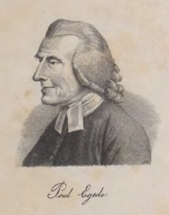

On page 21 the students write their own diary. They are to imagine that they live in Sermermiut and that Poul Egede visits them one day in 1737. They could for example tell about:
- What did they talk about?
- What did they get to eat?
- Do they believe in the shaman?
- Do they believe in Jesus?

The halibut from the Icefjord, pages 22-23
On page 22 the students can read about the halibut and see a picture of a halibut.
On page 23 the students find a facts box with more information about the halibut.
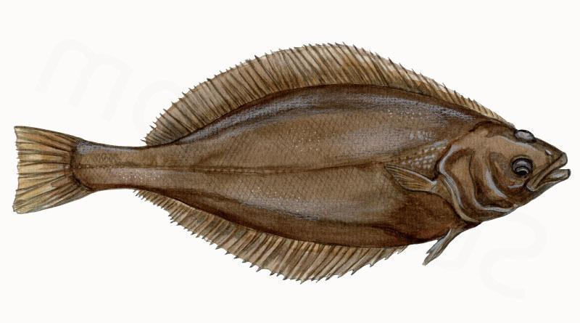

Facts  - The halibut lives in the ocean  - It can become up to 130 cm long  - It can weigh up to 45-50 kg  - The female is normally the biggest  - When it is 9-10 years old it lays up to 60.000 eggs  - It spawns from May till August  - It eats fish; for example small codfish and shrimps | Did you know?  The Greenland halibut is a valued and good edible fish that is of great importance to Greenland.  It is caught with nets, longlines or by trawl.  In winter the halibut fishing from the ice near Ilulissat is quite considerable.  It is the only flatfish that does not just live at the bottom of the sea. Halibut fishing has been going on for more than 4000 years in the sea around Ilulissat.

On page 23 the students draw a picture of a halibut and insert it in the book.

Flatfish, pages 24-25
On page 24 the students are to search for pictures of:
- a plaice
- a sole
- a halibut
The pictures are inserted into the three empty frames.
For each picture the students record an audio file where they tell a little about the fish and where you can catch it.
Let the students find pictures of more flatfish and perhaps tell more about them if they wish to do so.
Insertion of pictures and text: see instruction 2 and 3 here.

My reference book, pages 26-27
On these pages the students write sentences or small stories using the keywords and concepts that you have been through. They can write them, record them as an audio file or make a drawing and insert the picture. Their products will be used in the further work with the podcast.

Sound recording and insertion of pictures see instruction 1 and 2 here.

The town of the halibut, pages 28-29
As a conclusion, the students now create a visual story where they make use of the knowledge they have acquired in their work with the podcast. They can choose to draw their story, search for pictures or mix the two. Maybe they have other ideas themselves.

Insertion of pictures and drawings: see instruction 2 and 4 here.

Evaluation
The students show their products to the class.
Make sure that the framework for feedback is positive criticism. The students should be supported in assessing what is good – and what might be done better. Find more inspiration here.
Not specifically with a view to making new products, but foremost to let the students discover and work with this kind of constructive and positive criticism.
If you intend to work with some of the other podcasts from the Icefjord Centre, it might make sense to save the students’ Book Creator book, so the work they have done with it can be used again.

If you wish to let the students make use of the feedback they have received from the class, you could reserve time for them to continue their work with their products. So that they can use the feedback they have received from each other to change things in their product.
Colophon
The podcast The Town of the Greenland Halibut has been created by the Icefjord Centre in Ilulissat. The teaching material for the podcast The Town of the Greenland Halibut has been developed by Lotte Brinkmann and Daniella Maria Manuel, Anholt Læringsværksted with feedback from Leg med IT.

The student’s book in Book Creator has been developed by Rikke Falkenberg Kofoed and Daniella Maria Manuel, Leg med IT.
The teaching material The Town of the Greenland Halibut is published under a Creative Commons crediting licence CC:BY.
The texts, assignments and pictures can be shared, reproduced and adapted, with the proviso that “The Town of the Greenland Halibut by The Icefjord Centre Ilulissat” is credited as the source.

